**Chapter 6: CONVERSIONS – II**

**Topic – 1: Mealy Machine To Moore’s Machine**

**Steps Involved**

* **Step 1:** Let’s say state **qi** receives **'n'** unique inputs, then draw its each possible **qi/n** state.
* **Step 2:** Draw the lines, some lines have to be drawn **multiple times** from each of its **qi/n** state.

**Tips!**

**🡪 Recheck the lines, you might have been mistaken between input & output.**

**🡪 It is advised to use transition table during conversion.**

**Example**

**Ques:**

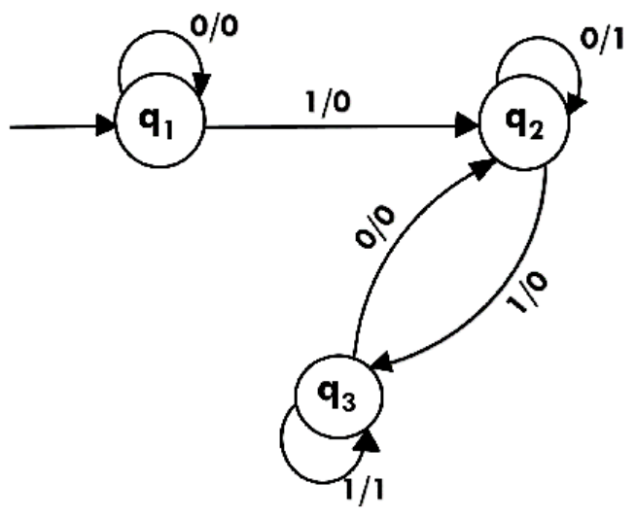

**Ans:**

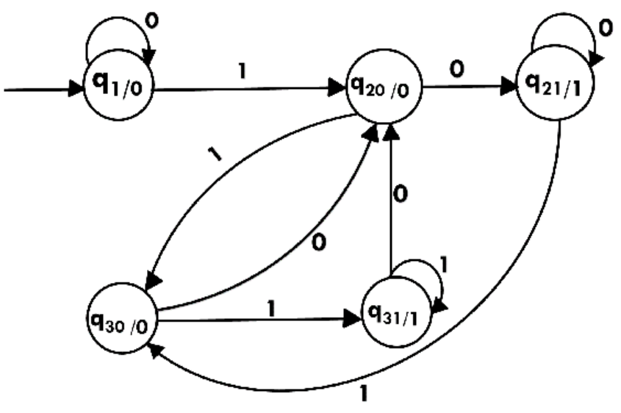

**Topic – 2: Moore’s Machine To Mealy Machine**

**Introduction**

* We **can’t** convert **Moore’s machine** to **Mealy machine** directly.
* So, we just change the way of **output distribution** in diagram.
* Means the state diagram **stays as it is**, but we write the outputs on the **transition lines** instead of **inside states**.

**Example**

**Ques:**

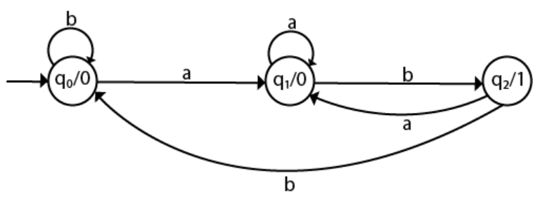

**Ans:**

